A

**Project Report**

on

**HEALTH NUTRITION CHATBOT**

Project report submitted in partial fulfilment of the requirement for the award

of the Degree of

**BACHELOR OF TECHNOLOGY**

**In**

**COMPUTER SCIENCE & ENGINEERING**

Submitted by

**S. KRISHNAVENI – R180893**

**P. DIVYA – R180897**

Under the guidance of

**M.MUNI BABU**

**M. Tech, (Ph.D), Assistant Professor**



**Rajiv Gandhi University of Knowledge Technologies (AP IIIT)**

**RK Valley,** Kadapa (Dist.), Andhra Pradesh, 516330

**Department of Computer Science and Engineering**

**2020-2024**

**­ Rajiv Gandhi University of Knowledge Technologies**

**RK Valley,** Kadapa (Dist.), Andhra Pradesh, 516330

**Department of Computer Science and Engineering**

**2020 -2024**

**CERTIFICATE**

This is to certify that the project work titled **“HEALTH NUTRITION CHATBOT”** is a Bonafede project work submitted by **S. KRISHNAVENI (R180893)**, **P. DIVYA** (R180897), in the department of **COMPUTER SCIENCE AND ENGINEERING** in partial fulfilment of requirements for the award of degree of Bachelor of Technology in **Computer Science and Engineering** for the year 2023- 2024 carried out the work under the supervision.

**Signature of Project Guide Signature of HOD**

GUIDE

M. MUNI BABU

M. Tech, (Ph. D)

Assistant Professor.

HEAD OF THE DEPARTMENT

Dr. P. Ravi Kumar

Ph.D (University of AIZU, Japan)

M.E (IISc Bangalore)

**Signature of External Guide**

**DECLARATION**

We hereby declare that the project report entitled **“HEALTH NUTRITION CHATBOT”** **submitted** to the **Department** of **COMPUTER SCIENCE AND ENGINEERING** in partial fulfilment of requirements for the award of the degree of **BACHELOR OF TECHNOLOGY.** This project is the result of our own effort and that it has not been submitted to any other University or Institution for the award of any degree or diploma other than specified above.

**WITH SINCERE REGARDS**

**S. KRISHNAVENI (R180893)**

**P. DIVYA (R180897)**

**ACKNOWLEDGEMENT**

The satisfaction that accompanies the successful completion of any task would be incomplete without the mention of the people who made it possible and whose constant guidance and encouragement crown all the efforts success.

I am extremely grateful to our respected Director, **Prof. A V S S KUMARA SWAMI GUPTA** for fostering an excellent academic climate in our institution.

I also express my sincere gratitude to our respected Head of the Department **Dr. P. Ravi Kumar** for his encouragement, overall guidance in viewing this project a good asset and effort in bringing out this project.

I would like to convey thanks to our guide at college **Mr. M. MUNI BABU** for his guidance, encouragement, co-operation and kindness during the entire duration of the course and academics.

My sincere thanks to all the members who helped me directly and indirectly in the completion of project work. I express my profound gratitude to all our friends and family members for their encouragement.

**Table of Contents**

|  |  |  |
| --- | --- | --- |
| **S.NO** | **INDEX** | **PAGE NO** |
|  | Abstract | ii |
|  | List of Figures | iii |
| I. | Introduction   * Problem Statement | 01-02  02 |
| II. | Literature Review   * Motivation * Contribution | 03  03  04-11 |
| III. | Modules  Module-1: Install and import Python libraries  Module-2: Load training and testing data   * Module-2.1: Load symptom description * Module-2.2: check symptom pattern   Module-3: Predict disease and get description | 12  13-19  15-18  19  20-22 |
| IV. | Results and Discussion | 23-25 |
| V. | Conclusion and Future Enhancements | 26 |
|  | References | 27 |

**Abstract:**

To start a good life, healthcare is more important. Todays people are busy with their works at home, office works and more addicted to Internet. They are not concerned about their health. So they avoid to go hospitals for small problems. It may become a major problem. So we create a Health Nutrition Chatbot using machine learning that can find the disease before consulting a doctor. The chatbot provides text you can communicate with bot like user friendly. The chatbot will clarify the users symptoms by asking questions, here symptom confirmation will be done.

Bot will provides which type of disease you have based on user symptoms. The disease will be categorized as minor and major disease. Chatbot will reply whether it is a major or minor disease. For major disease it appeared consult a doctor and for minor disease it provides precautions like food suggestion that means which type of food you have to take, especially vegetables and fruits and its uses to increase nutrition levels. Health Nutrition chatbot reduce the healthcare cost and time of the users as it is not possible for the users to visit the doctors or experts when immediately needed.

Mainly by using N-gram algorithm, Term frequency–inverse data frequency (TF-IDF) and Cosine similarity algorithms we are implementing Health Nutrition chatbot.

**LIST OF FIGURES**

|  |  |  |
| --- | --- | --- |
| **Figure No.** | **Title** | **Page No.** |
| **Figure 1.1** | Health Nutrition chatbot | 01 |
| **Figure 1.2** | Complete process of Health Nutrition Chatbot | 02 |
| **Figure 2.1** | Data flow diagram | 06 |
| **Figure 3.1.1** | Import python libraries | 12 |
| **Figure 3.2.1** | Training and testing data | 13 |
| **Figure 3.2.2** | Code for training and testing data | 14 |
| **Figure 3.2.1.1** | Load the symptom description, precaution and severity | 15 |
| **Figure 3.2.1.2** | Code for symptom_description | 15 |
| **Figure 3.2.1.3** | Symptom_description data | 16 |
| **Figure 3.2.1.4** | Code for symptom_severity | 16 |
| **Figure 3.2.1.5** | Symptom_severity data | 17 |
| **Figure 3.2.1.6** | Code for symptom_precautions | 17 |
| **Figure 3.2.1.7** | Symptom_precaution data | 18 |
| **Figure 3.2.2.1** | Code for symptom pattern | 19 |
| **Figure 3.3** | Code for predict the disease | 20 |
| **Figure 3.3.1** | Code for getting the details of precautions, suggest fruits and vegetables and its uses | 22 |
| **Figure 4.1** | Run the majorproject.py | 23 |
| **Figure 4.2** | By run the majorproject.py this will open | 23 |
| **Figure 4.3** | Entering the inputs | 24 |
| **Figure 4.4** | Precautions, suggest fruits and vegetables and its uses | 25 |

**LIST OF TABLES**

|  |  |  |
| --- | --- | --- |
| **Table No** | **Title** | **Page No** |
| 1 | Literature Review | 3 |
| 2 | Calculation of cosine similarity algorithm | 10 |

**I. INTRODUCTION**

Now a days, health care is very important in our life. Today’s people are busy with their works at home, office works and more addicted to internet. They are not concerned about their health. So, they avoid to go in hospitals for small problems. It may become a major problem. So, we create a Health Nutrition chatbot using machine learning that can find the disease before consulting a doctor. The chatbot provides text you can communicate with bot like user friendly. The chatbot will clarify the user’s symptoms by asking questions here symptom confirmation will be done. Chatbot will provides which type of disease you have based on user symptoms. The disease will be categorized as minor and major disease. Chatbot will reply whether it is a major or minor disease.

For major disease it appeared consult a doctor and for minor disease it provides precautions like food suggestion that means which type of food you have to take, suggest fruits and vegetables and its uses to increase nutrition levels. Health Nutrition chatbot reduce the healthcare cost and time of the users as it is not possible for the users to visit the doctors or experts when immediately needed.

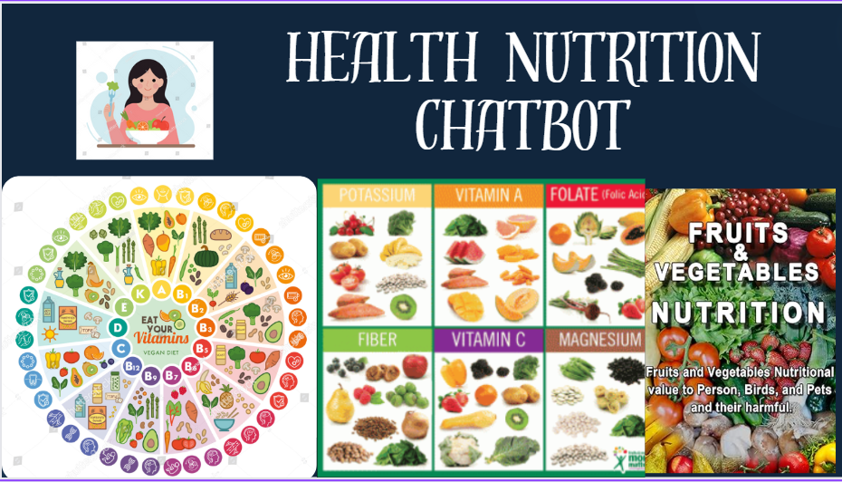

**Figure 1.1: Health Nutrition** **chatbot**

As shown in figure 1.1, Health Nutrition chatbot contains precautions like food suggestions, suggest fruits and vegetables and its uses for our healthy life.

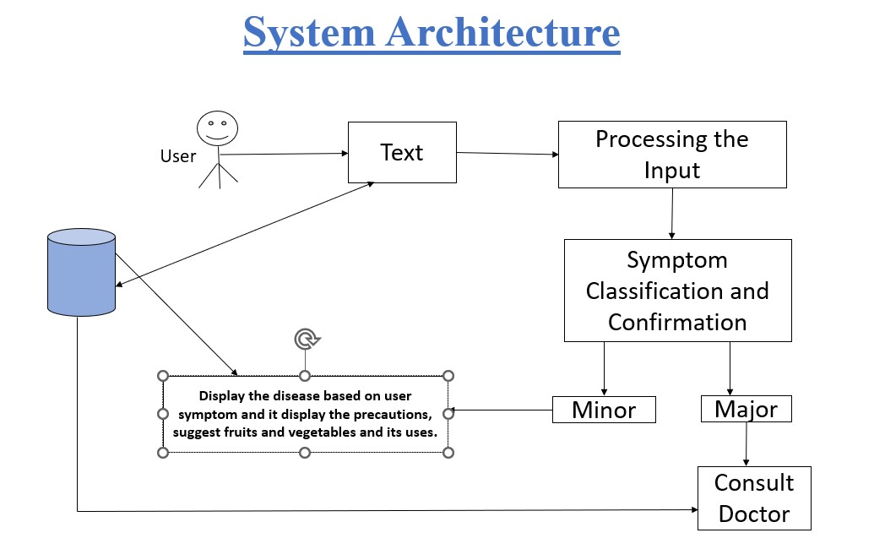

**Figure 1.2:** Complete process of Health Nutrition chatbot

As shown in figure 1.2, architecture of Health Nutrition chatbot. It explains about the working of the project form beginning to ending. Firstly, user text his or her name and enter the symptom then processing the input and confirm whether it is major or minor disease. If it is major consult a doctor otherwise display the precautions, suggest fruits and vegetables and its uses for minor diseases.

**Problem Statement:**

We have live chats through text and it may charge amount to perform live chat or telephony communication. So, Health Nutrition chatbot is help to user can chat with the bot regarding the health query through text, to reduce the health care cost and time of the users. Now a days people show interest on interface like chatbot because it gives friendly response that’s why we are using Health Nutrition chatbot. User can also view the food suggestion that means which type of food you have to take, suggest fruits and vegetables and its uses.

**II. LITERATURE REVIEW**

**Table 2.1:** Literature Review

|  |  |  |  |  |
| --- | --- | --- | --- | --- |
| **Year** | **Author** | **Method** | **Outcome** | **Drawback** |
| 2023 | Al-Hajri et al. | NLP (Natural Language Processing) | Satisfactory user satisfaction and engagement. | Limited data, user trust. |
| 2022 | Ali et al. | Support Vector Machine | High accuracy in symptom classification and disease prediction. | Biased data, limited technical capabilities. |
| 2021 | Kadam et al. | Deep Learning | Improved diagnosis support through medical image analysis. | Complex model development, limited data. |
| 2020 | Pradeep et al. | Reinforcement Learning | Enhanced chatbot performance with increased user interaction. | Black-box nature of the algorithm, privacy concerns. |
| 2019 | Verma et al. | Multilingual NLP | Effective communication with diverse populations. | Language accuracy limitations, user acceptance. |

**Motivation:**

The motivation for creating Health Nutrition Chatbot is when we are in hostel, we cannot able to consult doctor for minor diseases and we have seen some members at hostel get more depressed for small problems and in that situation there will no parents at hostel to suggest and support, so by this Health Nutrition Chatbot we clear our health queries and follow the suggestion that means which type of food you have to take, suggest fruits and vegetables and its uses. It provides the services at any time. By taking fruits and vegetables to increase our nutrition levels, especially students in hostel and workers in organization. Now a days people show interest on interface like chatbot because it gives friendly response that’s why we are using Health nutrition Chatbot.

**Contribution:**

Health Nutrition Chatbot is used to communicate with users through textual method. It is a health care provider and help to improve their performance by interacting with users in a human-like way. It helps the people before consulting a doctor to know their health conditions. In order to make communications more effective we are implementing a chatbot for health suggestions. Chatbot is based on Machine Learning and Users Natural Language Process (NLP) to interpret and accordingly respond to the user. N-gram algorithm, Term Frequency (TF) is used to build a model with the goal of understanding text and stop words being removed. Inverse Document Frequency (IDF) determines the weight of rare words. Cosine Similarity algorithm is a measure of similarity between two non-zero vectors of an inner product space that measures the cosine of the angle between them.

**Technologies Used:**

**Python:**

Python is an excellent programming language for building software application like chatbots due to its simplicity and versatility, and the availability of various libraries and frameworks. Python extensive libraries, and robust community support make it an ideal choice for building chatbots with advanced features like natural language processing, machine learning. Python is a computer programming language often used to build websites and software automated tasks and conduct data analysis. python is a general-purpose language Meaning it can be used to create a variety of different programs and isn’t specialized for any specific problems. this versatility along with its beginner’s friendliness has made it one of the most used programming languages today.

**Uses of python:**

python is commonly used for developing websites and software task automation data analysis and data visualization. Since it’s relatively easy to learn python has been adopted by many non-programmers such as accountants and scientists for a variety of everyday tasks like organizing finance.

* data analysis and machine learning

**Python Libraries:**

**NumPy:**

NumPy is a python library used for working with arrays it also has functions for working in domain of linear algebra flourier transform and matrices. NumPy stands for numerical python. In python we have lists that serve the purpose of arrays but they are slow to process. NumPy aims to provide an array object that is up to 50 times faster than traditional python list the array object in NumPy is called Nd array. It provides a lot of supporting functions that make working with Nd array very easy.

**Pandas:**

Pandas is a python library used for working with datasets. It has functions for analysing cleaning exploring and manipulating data. The name pandas have reference to both panel data and python data analysis and was created by wes mckinney in 2008.

**Regular Expression(re):**

Regular expressions are special sequence of characters that uses a search pattern to find a string or set of strings it can detect the presence or absence of a text by matching it with a particular pattern and also can split a pattern into one or more sub patterns. Python provides are module that supports the use of regex in python its primary function is to offer a search.

**Scikit-Learn:**

Scikit-learn is an open-source python library that implements a range of machine learning preprocessing cross validation and visualization algorithms using a unified interface. Important features of scikit-learn: simple and efficient tools for data mining and data analysis.

**CSV:**

Common separated values (csv) module was incorporated in python’s standard library as a result of PEP 305. CSV is a preferred export data format by Microsoft’s Excel spreadsheet software.

**Data Flow Diagram:**

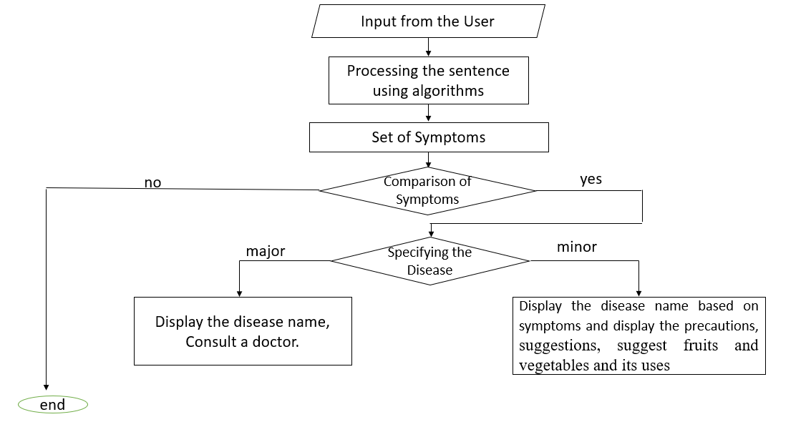

**Figure 2.1:** Data Flow Diagram

As shown in figure 2.1, data flow diagram explains about the process of Health Nutrition Chatbot. Firstly, take the input from the user such as name and symptom. After that processing the input chatbot will confirm the disease by asking questions. Based on the user response chatbot specify the disease whether it is major or minor. If it is major disease display the disease name and consult a doctor. If it is minor disease display the disease name and precautions like suggest fruits and vegetables and its uses.

**Algorithms:**

We are using three algorithms to implement Health Nutrition Chatbot.

1. N-gram Algorithm

2. Term Frequency - Inverse Data Frequency (TF-IDF)

3. Cosine similarity algorithm

**1. N-gram Algorithm:**

N-Grams are way to help machines understand a word in the content to get a better understanding of word. N-gram is a neighbouring sequence of n-items from a given sample of text. N-items means we can have two items, three items and so on. So, it is a contiguous sequence of some items.it helped to predicting the next words in a sentence. Things will be characters, words, sentences. When n is 2 then we can call it as bigrams and n is 3 then we can call it as trigrams. Based on sentence we can change the value of ‘n’.

**Advantages:**

**1. *Simple and Efficient*:** N-gram models are relatively simple and computationally efficient compared to more complex language models. This simplicity allows for quick implementation and processing.

**2.** ***Captures Local Context***: They capture the local context of words in a sequence. For example, a trigram model (3-gram) considers the probability of a word based on the two preceding words, which can help in tasks like text prediction or completion.

**3. *Useful in Language Generation:*** N-grams are effective in generating text, such as in machine translation or autocomplete features, by predicting the next words based on the preceding sequence.

**4. *Feature Extraction***: In some machine learning applications, N-grams serve as useful features for text classification tasks like sentiment analysis or spam detection. They capture word combinations that might be indicative of specific classes or categories.

**5. *Scalability*:** They can be adapted to different sizes (unigram, bigram, trigram, etc.) depending on the level of context needed, making them flexible for various NLP tasks.

**Disadvantages:**

**1. *Limited Context***: N-gram models have a limited context window based on the 'n' value chosen. This limitation can lead to a lack of understanding of broader semantics or dependencies beyond the chosen 'n' words.

**2. *Fixed Length***: The length of the sequence is fixed based on the chosen 'n' value, potentially leading to difficulties in handling variable-length sequences or capturing long-range dependencies.

**3. *Overfitting*:** Higher 'n'-gram models are prone to overfitting, especially when dealing with limited training data. This is due to the model memorizing specific sequences rather than generalizing well to unseen data.

**2. Term Frequency-Inverse Data Frequency (TF-IDF):**

**Term Frequency (TF):**

when building a model with the goal of understanding text, you’ll see all of stop words being removed. Another approach is to score the relative importance of words using TF-IDF.

The number of times a word seems during a document divided by the total number of words in the document. Each document has its own term frequency.

tfi,j= ni,j /∑k nij (i)

* nij = the number of times a word appears in a document.
* ∑k nij = total number of words in the document.

Every document has its own term frequency.

Example1: I am suffering from fever.

Example2: I am suffering from headache.

* TF = Number of occurrences / Number of words in document.

Example1: Example2:

TF1 = 1/5 = 0.2 TF1 = 1/5 = 0.2

TF2 = 1/5 = 0.2 TF2 = 1/5 = 0.2

TF3 = 1/5 = 0.2 TF3 = 1/5 = 0.2

TF4 = 1/5 = 0.2 TF4 = 1/5 = 0.2

TF5 = 1/5 = 0.2 TF5 = 1/5 = 0.2

**Inverse Data Frequency(IDF):**

The log of the number of documents divided by the number of documents that contain the word **w**. Inverse data frequency determines the weight of unique words across all documents in the corpus.

idf(w) = log (N / dft)  (ii)

* N = Number of documents.
* dft = Number of documents that contain words.

Example1: I am suffering from fever.

Example2: I am suffering from headache.

Idf = log (number of documents/number of documents contain a word)

IDF(I) = log (2/2) = 0

IDF (am) = log (2/2) = 0

IDF (suffering) = log (2/2) = 0

IDF (from) = log (2/2) = 0

IDF (fever) = log (2/1) = 0.301

IDF (headache) = log (2/1) = 0.301

**Advantages:**

**1. *Term Importance***: TF-IDF helps identify the importance of a term in a document relative to a collection of documents. Terms that appear frequently in a document but rarely in other documents are considered more important.

**2. *Reduction of Common Terms***: Commonly occurring words like "the," "is," etc., tend to have lower TF-IDF scores due to their prevalence across documents. This helps in identifying and prioritizing more meaningful terms.

**3. *Flexible and Simple*:** It's a relatively simple algorithm to implement, yet it offers flexibility in capturing term importance based on frequency within a document and rarity across the entire document collection.

**4. *Normalization***: TF-IDF normalizes term frequencies, reducing the impact of document length on the importance of terms. This normalization allows for fair comparisons between documents of different sizes.

**5. *Useful in Text Classification****:* It's valuable for text classification tasks by highlighting discriminative terms that are more relevant to particular classes or categories.

**Disadvantages:**

**1. *Ignores Word Order and Semantics***: TF-IDF solely considers term frequency and document frequency but disregards word order or semantics. Hence, it might not capture the context or meaning of phrases or multi-word expressions.

**2. *Sensitive to Term Variations***: It treats each term independently, leading to challenges with variations of words (e.g., singular vs. plural, different verb tenses, synonyms), potentially overlooking their semantic similarity.

**3. Cosine Similarity Algorithm:**

Cosine similarity algorithm is a measure of similarity between two non-zero vectors of an inner product space that measures the cosine of the angle between them. The technique is also used to measure cohesion within clusters in the field of data mining.

TF * IDF  (iii)

|  |  |  |  |  |  |  |
| --- | --- | --- | --- | --- | --- | --- |
| **Documents** | **I** | **am** | **suffering** | **from** | **fever** | **headache** |
| Document 1 | 0.2*0 = 0 | 0.2*0 = 0 | 0.2*0 = 0 | 0.2*0 = 0 | 0.2*0.301= 0.012 | 0 |
| Document 2 | 0.2*0 = 0 | 0.2*0 = 0 | 0.2*0 = 0 | 0.2*0 = 0 | 0 | 0.2*0.301= 0.012 |

**Table 2.2:** Calculation of cosine similarity algorithm

**Advantages:**

**1. *Scale Invariant***: Cosine similarity is unaffected by the magnitude of the vectors but rather focuses on the direction, making it robust when dealing with documents of varying lengths or scales.

**2. *Ignores Magnitude:*** It considers the angle between vectors, not their magnitude, which is beneficial when comparing documents or text irrespective of their sizes or word counts.

**3. *Efficiency****:* It's computationally efficient, especially when dealing with high-dimensional spaces, making it suitable for large-scale document comparisons or similarity-based tasks.

**4. *Effective in Text Mining***: Cosine similarity is effective in text mining tasks such as document clustering, information retrieval, and content-based recommendation systems, as it helps quantify the similarity between documents or items based on their content.

**5. *Normalization*:** It implicitly normalizes the vectors, making comparisons fair and independent of the overall frequency of terms within documents.

**Disadvantages:**

**1. *Limited to Vector Space Models***: Cosine similarity requires data representation as vectors in a vector space model. Hence, it might not capture more complex relationships or non-linear structures present in the data.

**2*. Lack of Semantic Understanding***: It doesn't consider semantics or meaning, treating each term or dimension independently. This might lead to mismatches in similarity when comparing documents with similar meanings but different wording.

**III. MODULES**

**MODULE-1: Install and Import Python Libraries:**

Here, we install python libraries like regular expression(re), pandas, NumPy, warnings, sklearn and its models in pycharm.

We use below commands to install python libraries.

* pip install re
* pip install pandas
* pip install numpy
* pip install sklearn.tree
* pip install sklearn.model selection
* pip install warnings
* pip install sklearn.svm
* pip install streamlit

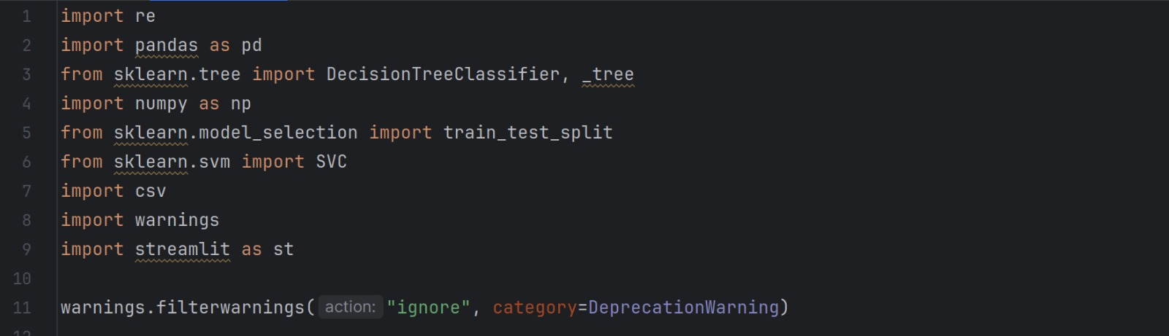

**Figure 3.1.1:** Import Python Libraries

As shown in figure 3.1.1, after successful installation we can import the above libraries in pycharm. Make sure that installation of all dependent libraries must before importing otherwise it will be showing error.

**MODULE-2: Load Training and Testing Data:**

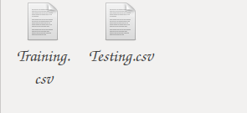

**Figure 3.2.1:** Training and testing data

As shown in figure 3.2.1, we can load training and testing data using training.csv as well as testing.csv files. The data can be trained and tested after pre-processing the data to give better results.

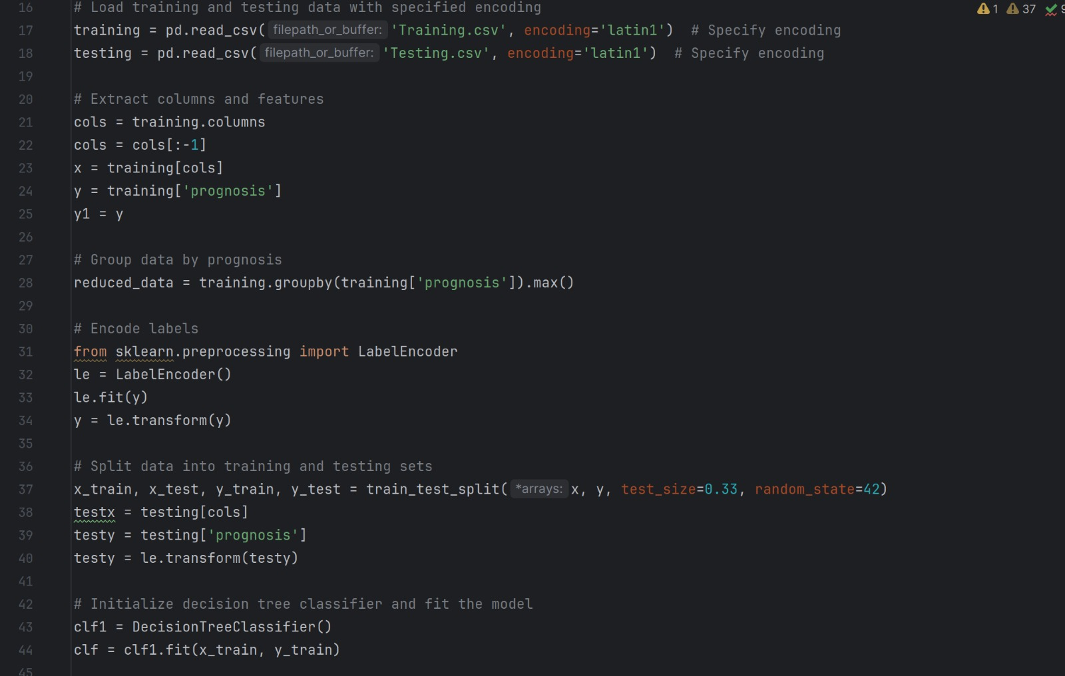

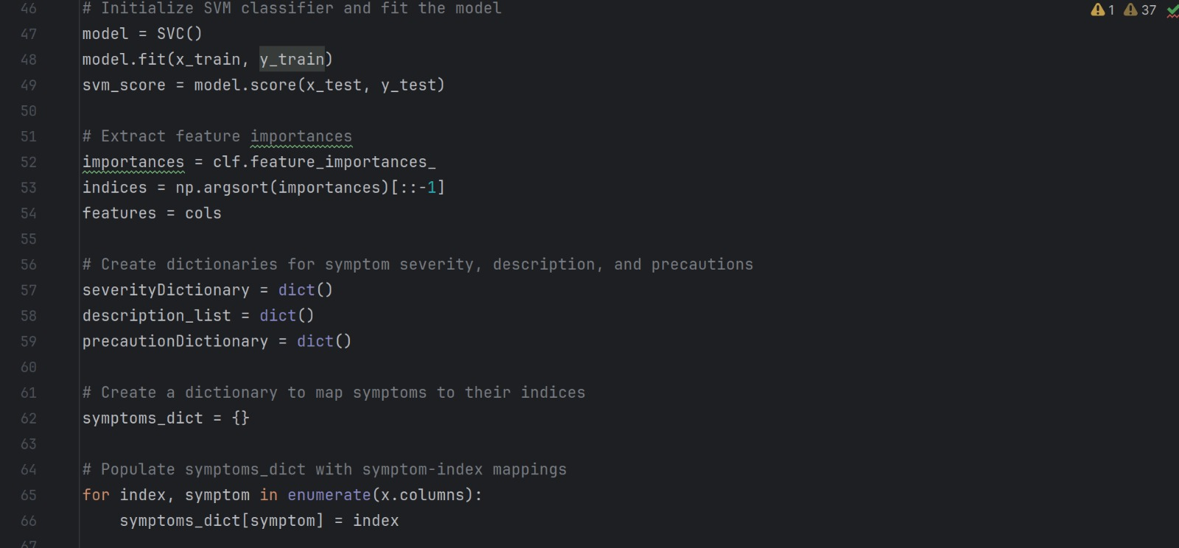

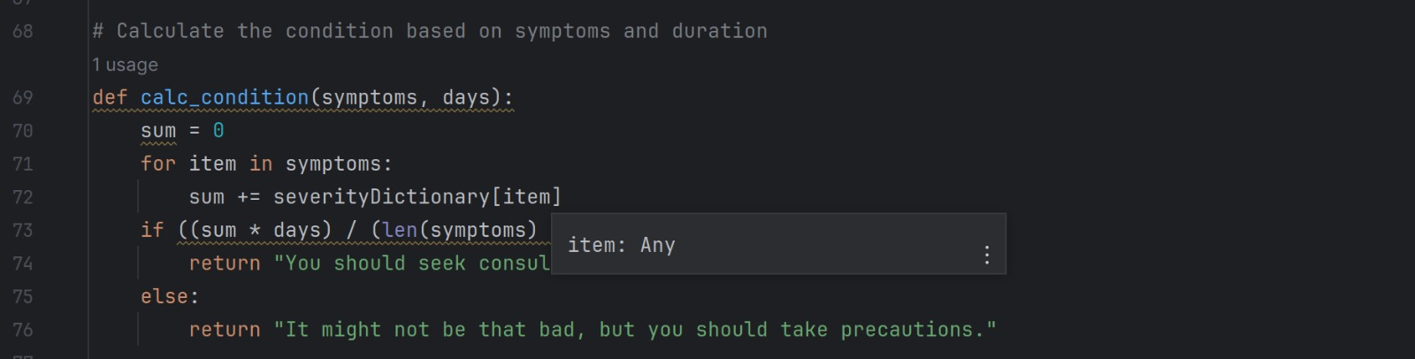

**Figure 3.2.2:** Code for training and testing data

As shown in figure 3.2.2, the code is for training and testing data using training.csv, testing.csv files. Here comma separated value(csv) files are used because of these files have a simple structure, human readable, storing the data can be easily imported or exported. So, csv files are used for training and testing the data.

**Module-2.1: Load symptom description**

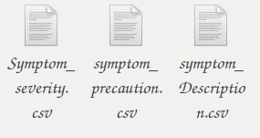

**Figure 3.2.1.1:** Load the symptom description, precaution and severity

As shown in figure 3.2.1.1, we can load the symptom description, precaution and severity files using Symptom_severity.csv, symptom_precaution.csv and symptom_Description.csv files.

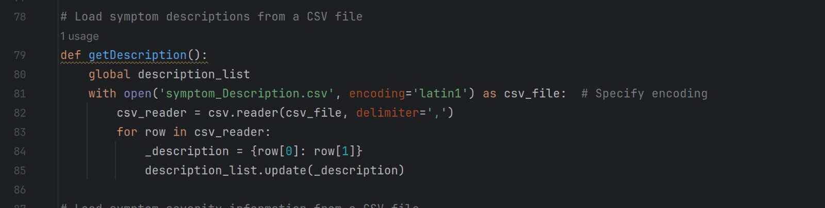

**Figure 3.2.1.2:** Code for symptom_Description

As shown in figure 3.2.1.2, the above code is for symptom description. Using symptom_Description.csv file gives the correct solution to the user about the disease. Here csv_reader used to read the csv file in which type of cases. For example, the above code consists of delimiter as ‘,’.

**Symptom_Description.csv file:**

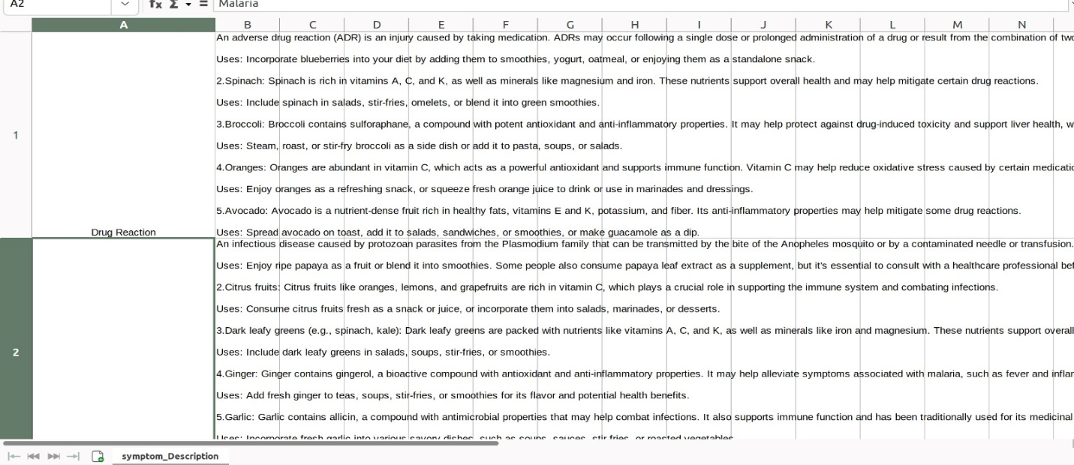

**Figure 3.2.1.3:** symptom_Description data

As shown in figure 3.2.1.3, the data is about symptom descriptions. It consists of disease name and its description that means the information about the disease in few lines. As well as it contains information about the fruits and vegetable its uses in detailed.

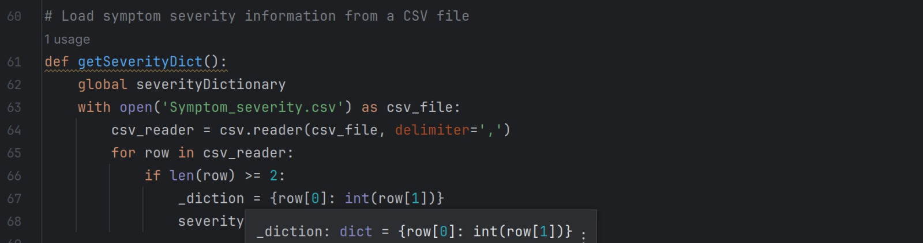

**Figure 3.2.1.4:** Code for symptom_severity

As shown in figure 3.2.1.4, the above code is for symptom severity. Using symptom_severity.csv file chatbot predict about the condition of the disease.

**Symptom_severity.csv file:**

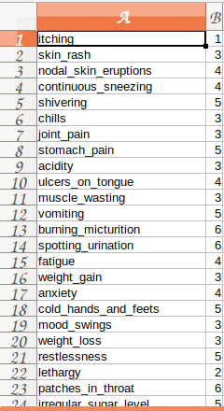

**Figure 3.2.1.5.** symptom_severity data

As shown in figure 3.2.1.5, the data is about symptom severity. It consists of severity of symptoms. The severity of symptoms decides whether it is major or minor disease.

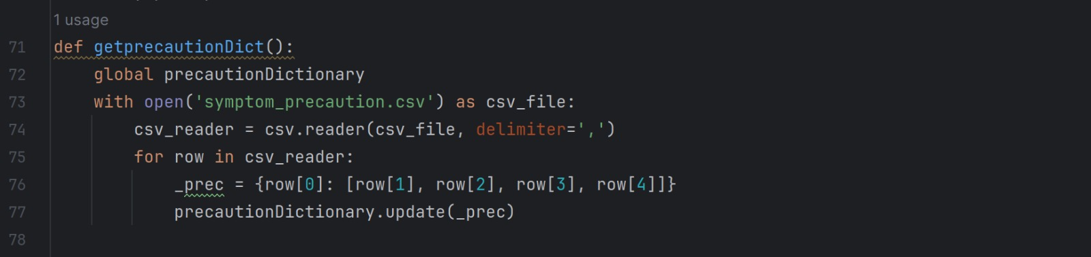

**Figure 3.2.1.6:** Code for symptom_precautions

As shown in figure 3.2.1.6, the above code is for symptom precautions. Using symptom_precautions.csv file Health Nutrition chatbot will give precautions such as which type of food we take and also suggest fruits and vegetables and its uses.

**Symptom_precautions.csv file:**

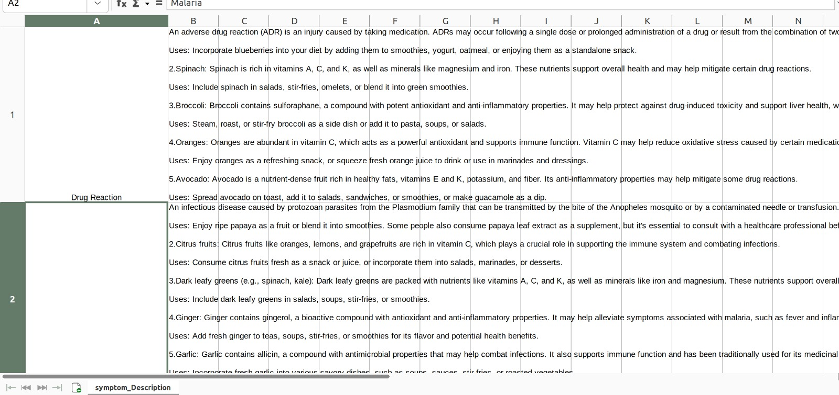

**Figure 3.2.1.7:** symptom_precaution data

As shown in figure 3.2.1.7, the data is about symptom precautions. It consists of precautions and suggest fruits and vegetables and its uses. Through that precautions user will know about fruits and vegetables and its uses.

**Module-2.2: Check symptom pattern:**

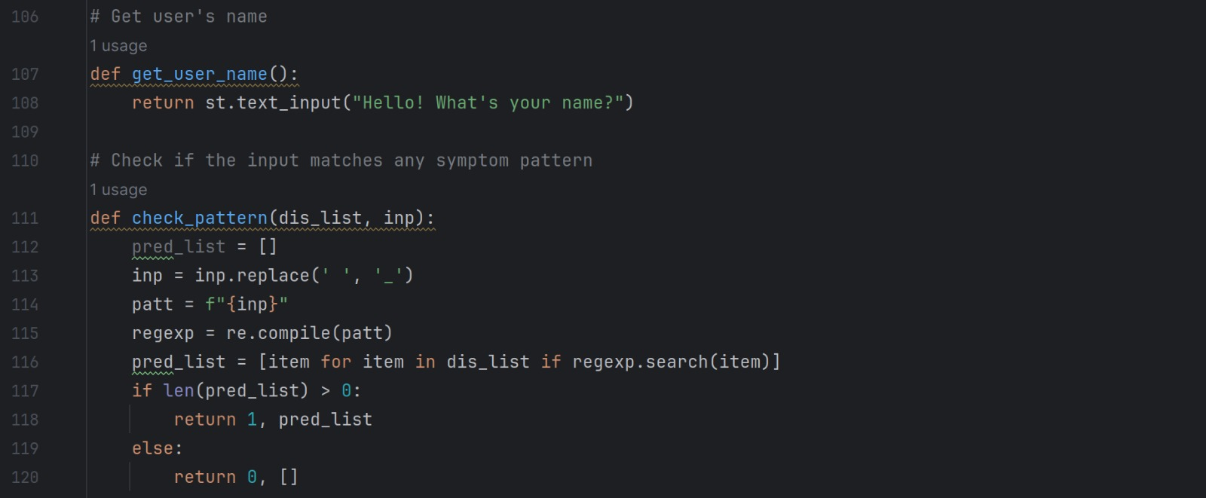

**Figure 3.2.2.1:** Code for symptom pattern

As shown in figure 3.2.2, the code is for symptom pattern. After entering the symptom, it checks if the input matches any symptom in the pre-processing data files or csv files.

**Module-3: Predict disease and get description**



**Figure 3.3:** Code for predict the disease

As shown in figure 3.3, the code is for disease prediction. Based upon symptom pattern matching chatbot will ask questions. Based upon our response it will predict the disease name.

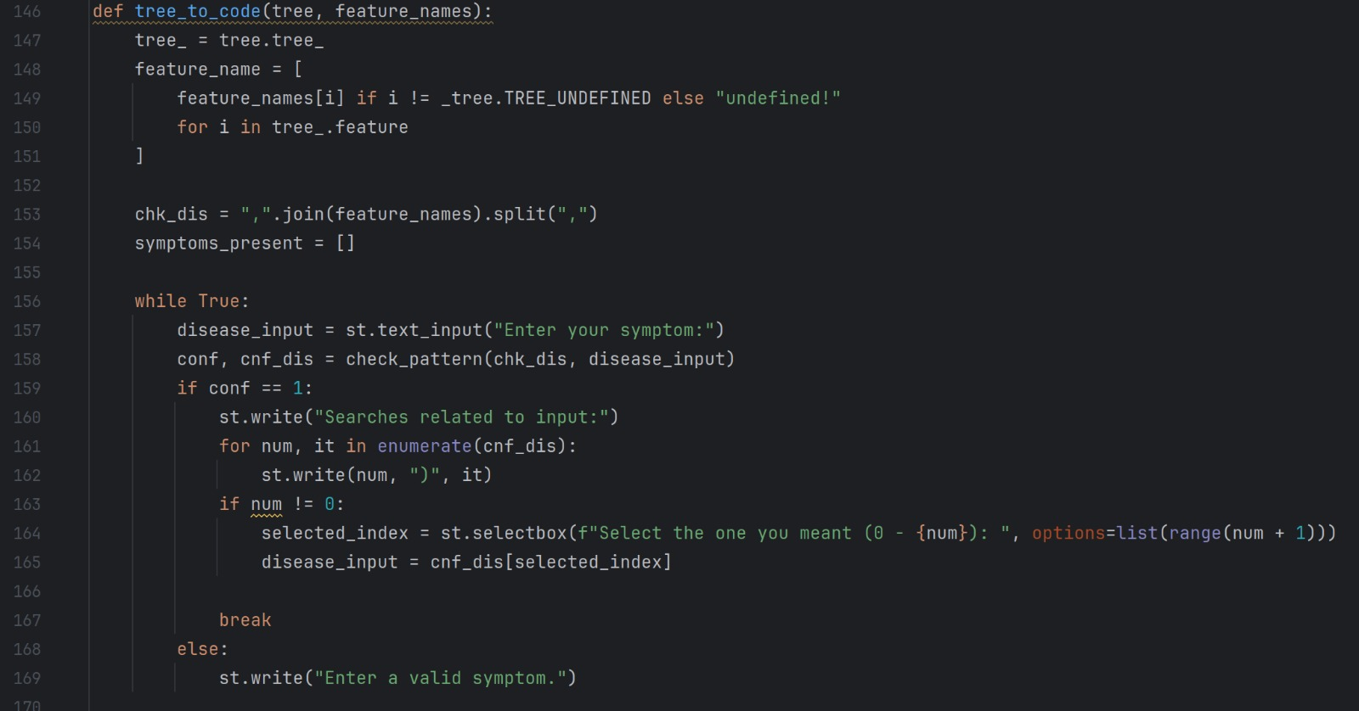

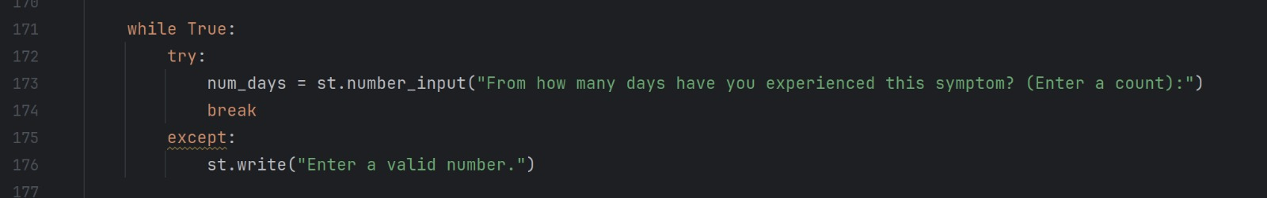

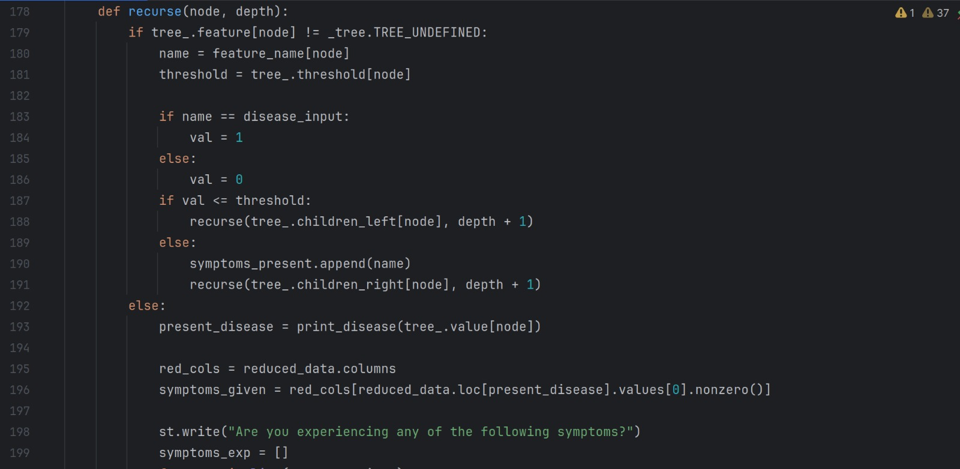

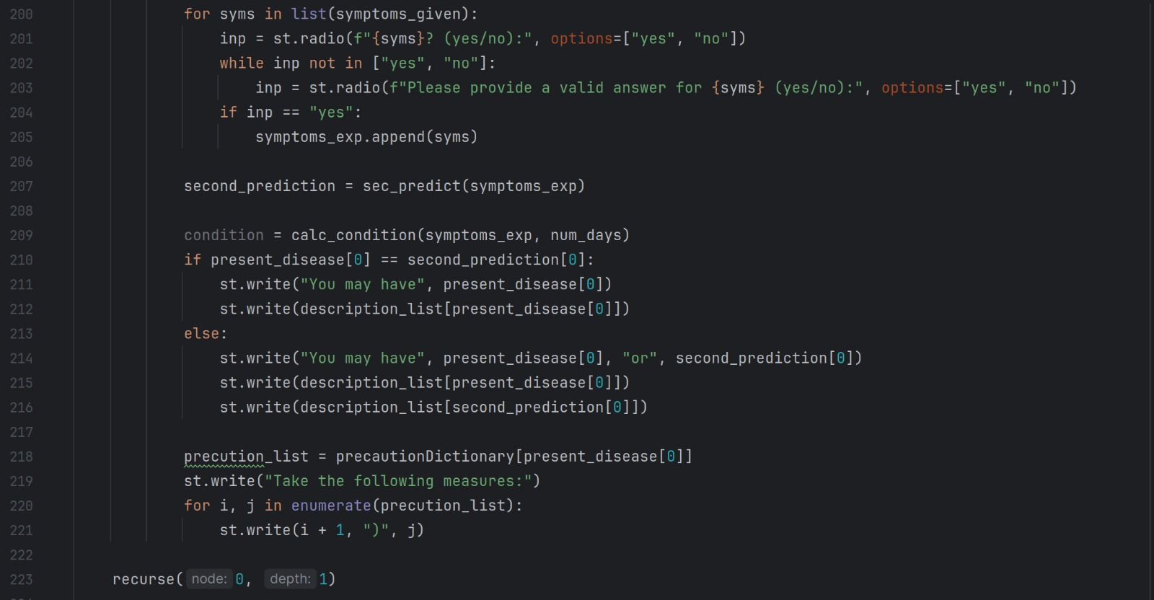



**Figure 3.3.1:** Code for getting the details of precautions, suggest fruits and vegetables and its uses.

As shown in figure 3.3.1, the code is for getting the details of precautions, suggest fruits and vegetables and its uses. In this code we use getseverityDict(), getdescription() and getprecautionDict() methods for getting the data that means solution to the particular disease.

**IV. RESULTS AND DISCUSSION**

As show in the below figures, we run the majorproject.py in pycharm. By running majorproject.py file then only the chatbot starts.

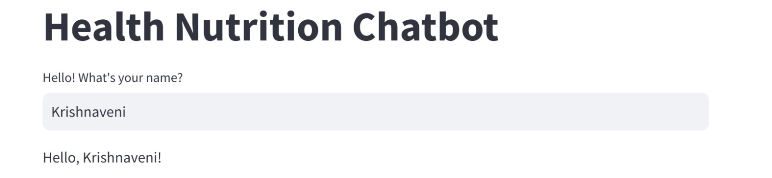

**Figure 4.1:** Run the majorproject.py file

As shown in figure 4.1, we run the majorproject.py code in pycharm.



**Figure 4.2:** By run the majorproject.py this will open

As shown in figure 4.2, By running the majorproject.py in pycharm it will show like enter a message that means enter your name.

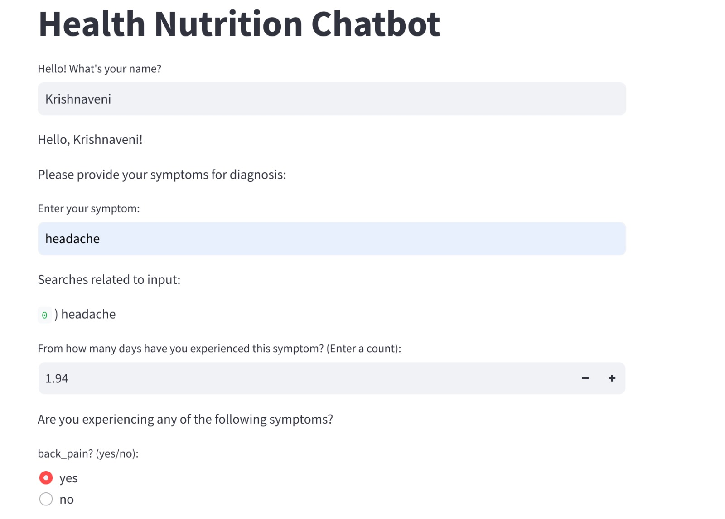

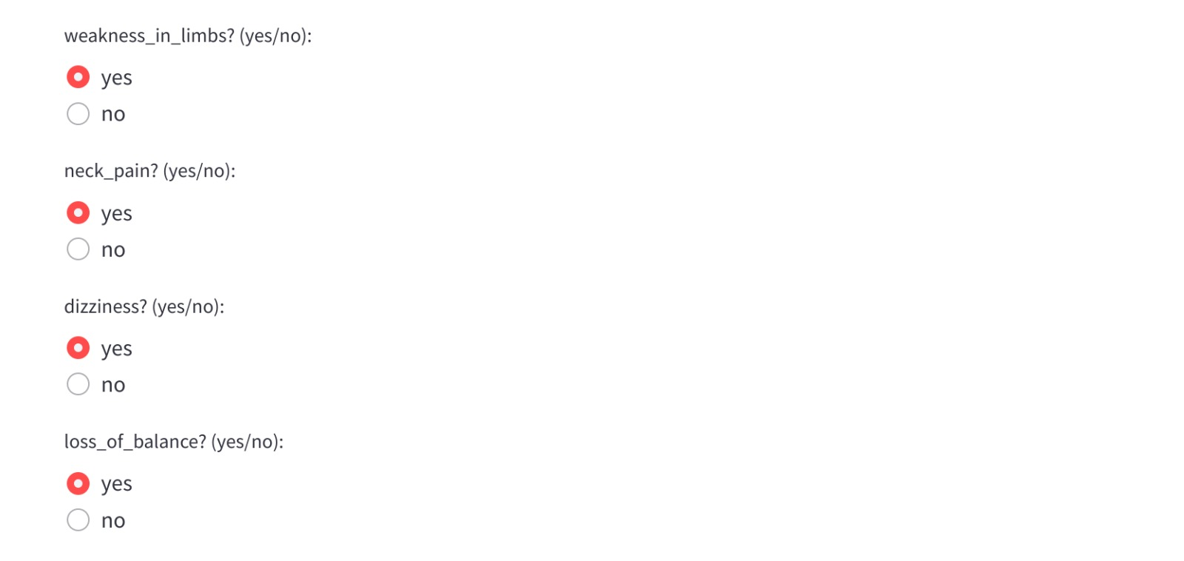

**Figure 4.3:** Entering the inputs

As shown in figure 4.3, enter user name, symptom and count that means suffering from how many days. Based on entering the details Health Nutrition Chatbot asks a questions. User respond and give answers to the chatbot like say yes or no.

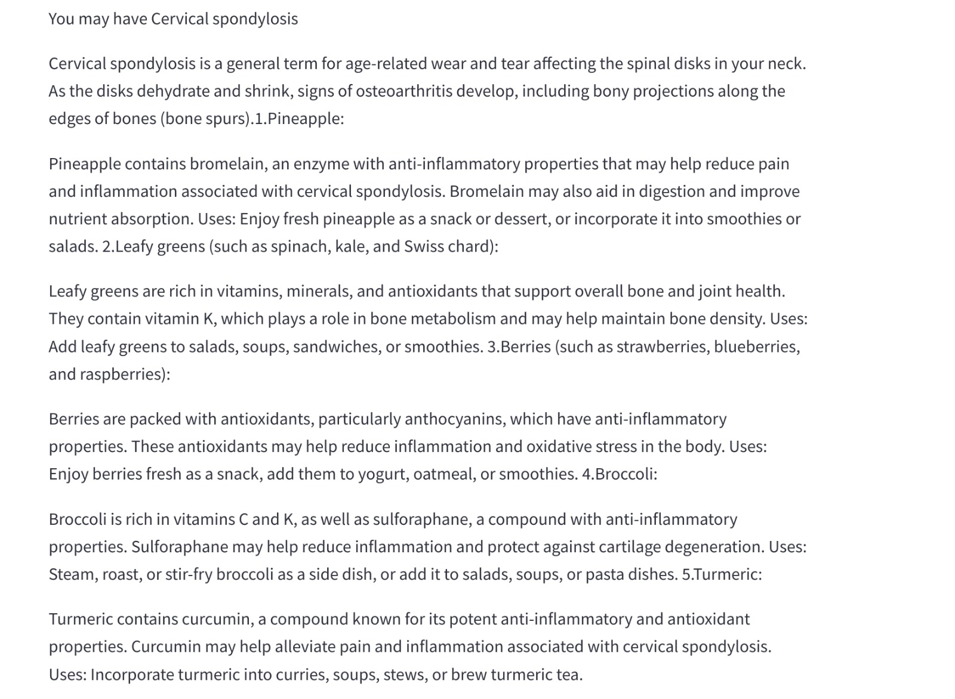

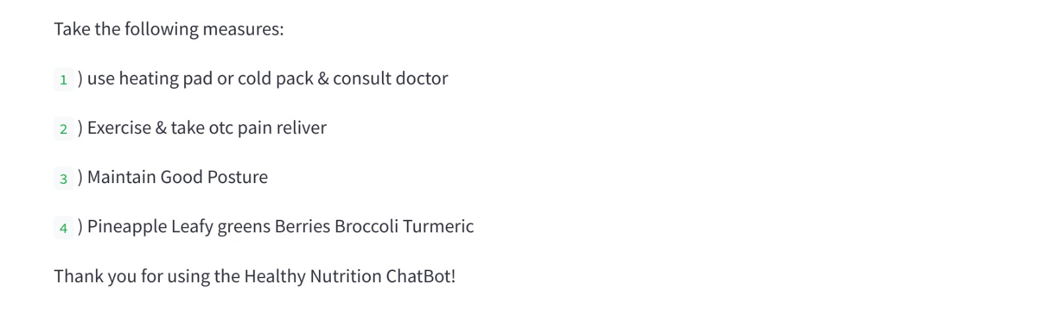

**Figure 4.4:** Precautions, suggest fruits and vegetables and its uses

As shown in figure 4.4, by entering the details and respond to the chatbot questions it will predict and confirm whether it is major or minor disease. If it is a major disease give suggestion like consult a doctor. If it is a minor disease give safety measures like precautions such as which type of food you have to take and suggest fruits and vegetables and its uses to increase nutrition levels.

**V. CONCLUSION AND FUTURE ENHANCEMENTS**

**Conclusion:**

Health Nutrition Chatbot provide precautions like food suggestions, suggest fruits and vegetables and its uses for the people by asking questions based on symptoms related to their health problem. This chatbot is very helpful to users as they can easily get precautions without paying and get a quick response from the chatbot which means without any delay it gives accurate results to the user.

**Future Enhancements:**

**1. Advanced Natural Language Processing (NLP):** Improving the chatbot's understanding and generation of natural language to better comprehend nuanced medical queries and provide accurate responses.

**2. Emergency Response Integration:** Equipping the chatbot to handle emergency situations by providing first aid guidance or connecting users to emergency services when necessary.

**3. Voice and Visual Interaction:** Progressing from text-based interactions to support voice recognition and possibly even visual analysis for physical symptoms.

**4. Real-time Monitoring and Alerts:** Developing capabilities for real-time monitoring of user health data (with proper consent) to provide immediate alerts or suggestions in case of any abnormalities.

**5. Personalized Recommendations:** Integrating machine learning algorithms to analyse user data (like medical history, lifestyle, genetic information) to offer personalized health recommendations and advice.

The future scope of this project is to enable machine to communicate with people in text format. So that people also easily communicate with machine. Also need to implement good interface. Try to improve accuracy of prediction by using sufficient data.

**REFERENCES**

[1] A. Al-Hajri, M. Al-Khalil, and A. Al-Masri, "Development of a Medical Chatbot Using Al," International Journal of Recent Performance and Practices, vol. 3, no. 9, 2022.

[2] M. A. Ali, A. El-Sappagh, M. A. Al-Ghamdi, and S. A. Salem, "Machine Learning Based Healthcare Chatbot," in 2020 IEEE International Conference on Communication Systems and Network Technologies (CSNT), vol. 4, no. 9, 2020.

[3] S. R. Kadam, G. S. Gadekar, and S. R. Kadam, "A Medical Chatbot using Machine Learning and Natural Language Understanding." Multimedia Tools and Applications, vol. 81, no. 1, pp. 1249-1271, 2022.

[4] A. S. Pradeep, V. N. A. Srinivas, and K. P. Reddy, "Building a Medical Chatbot using Support Vector Machine Learning Algorithm," Journal of Physics: Conference Series, vol. 1716, no. 1, p. 012059, 2021.

[5] S. Verma, A. Singh, U. Sharma, and S. Singh, "Multilingual Healthcare Chatbot Using Machine Learning," in 2020 International Conference on Computing, Communication, and Intelligent Systems (ICCCIS), vol. 4, no. 1, pp. 012058, 2020.